**Employee Management and Attendance Tracker**

**Create Database**

Firstly, Created the database for the project Emp_Project

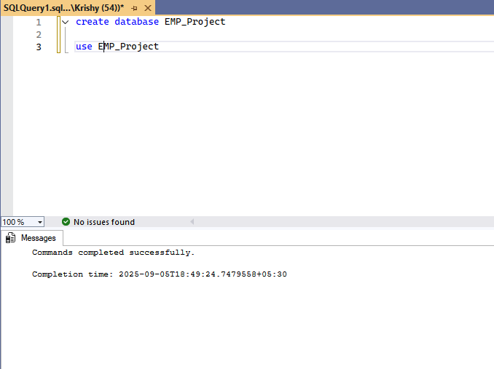

**Creating Table**

Table definitions for Departments and Roles

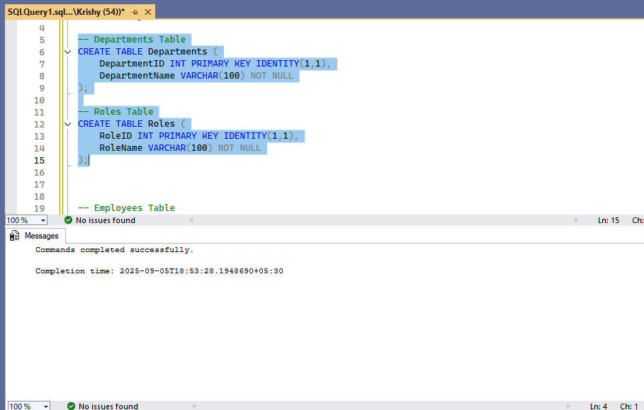

Table definitions for Employee and Attendance

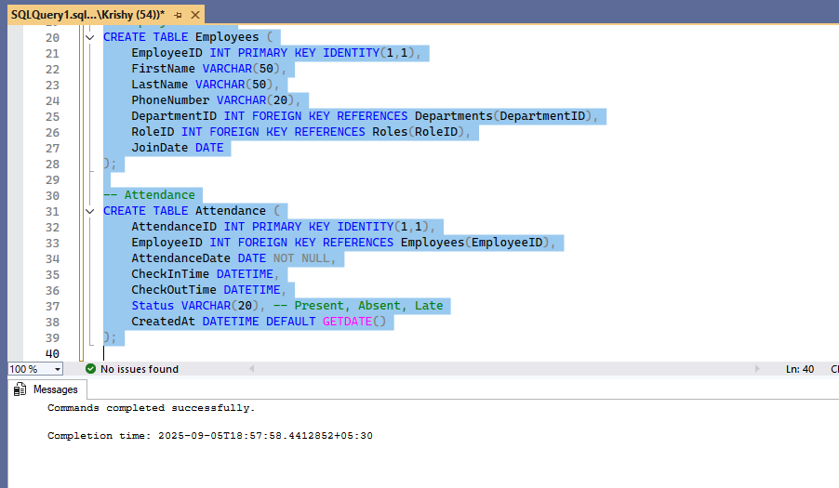

**Inserting Records**

Inserted records into department and roles tables only their names are inserted.

Id’s are auto populated as we give identity(1,1) – it will auto increment values with Primary key constraints.

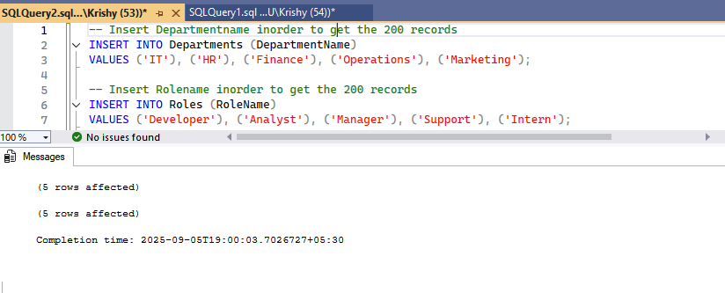

**Inserting 200 records in Employee and Departments Table**

Have got the dummy excel from google with same table and have incorporated into SQL.

For doing so, below are the steps which I followed…

* In SQL Server Management Studio, right-click on the database where the tables are located.
* Go to Tasks -> Import flat files
* Choose path and give name to that.
* Give next and click ok.
* It give Success state after the insertion is done.

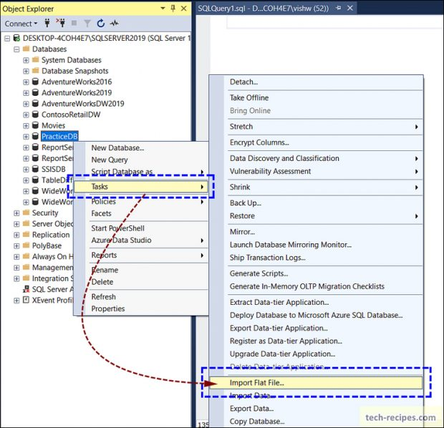

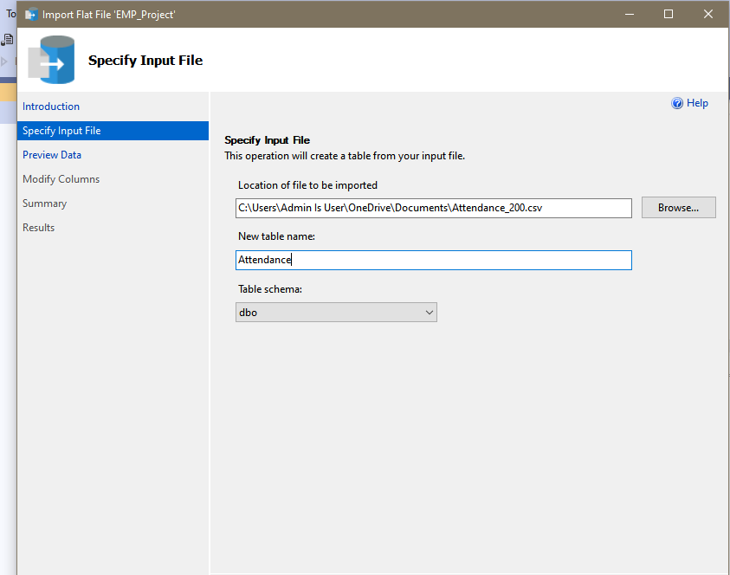

Now you can see the data are inserted.

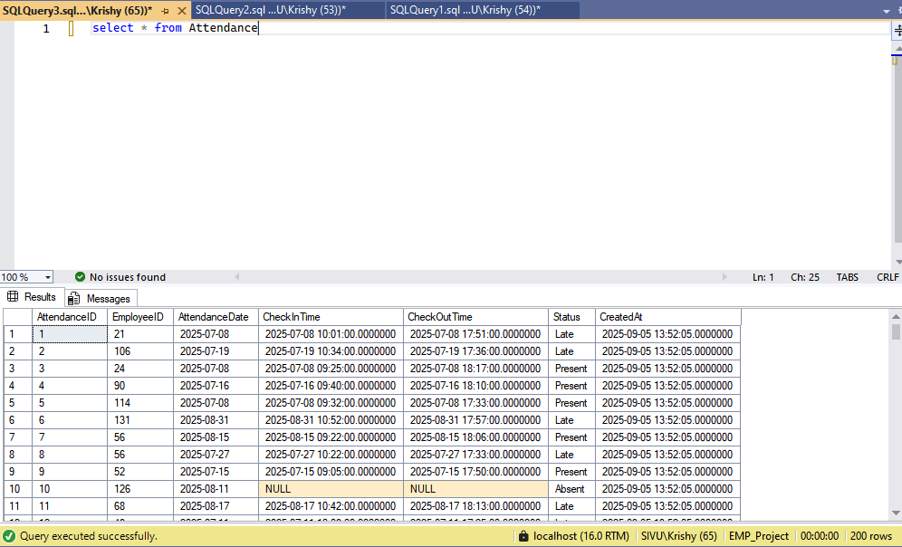

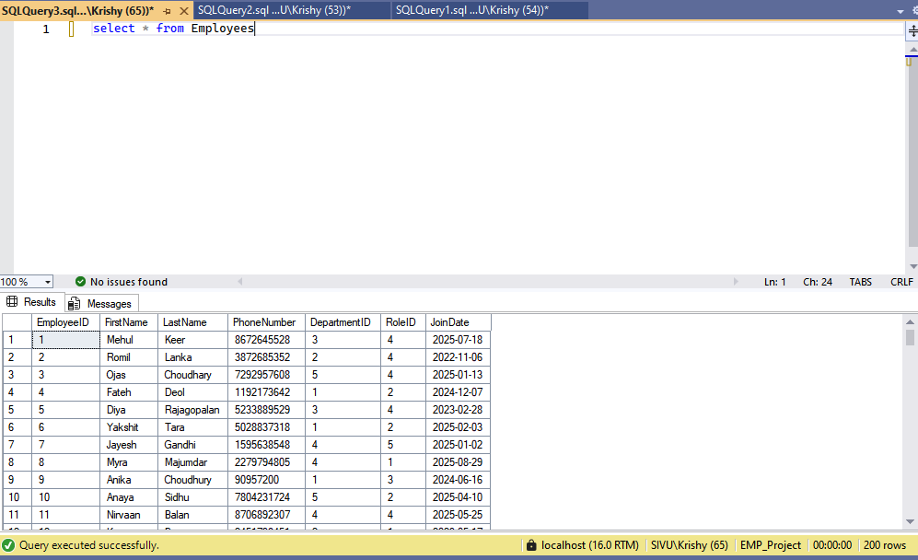

**Monthly attendance**

Here you see Monthly attendance for each students…

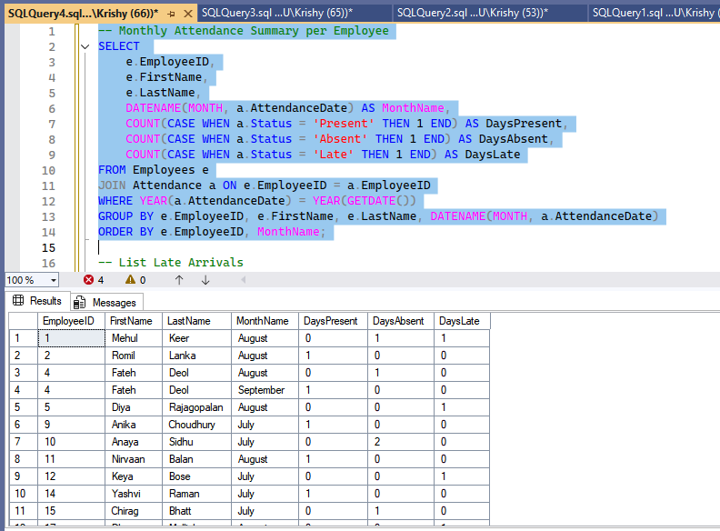

**Late arrivals**

Here you see Late arrivalsfor each students…

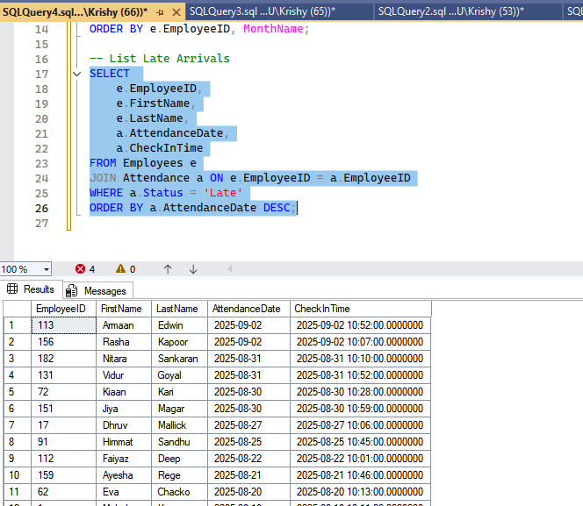

**Triggers**

Triggers are created for updating the records. 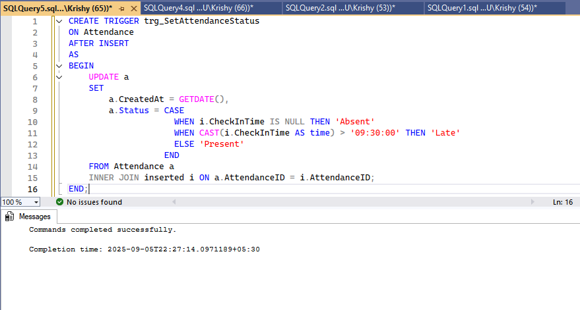

You can see the below records are updated.

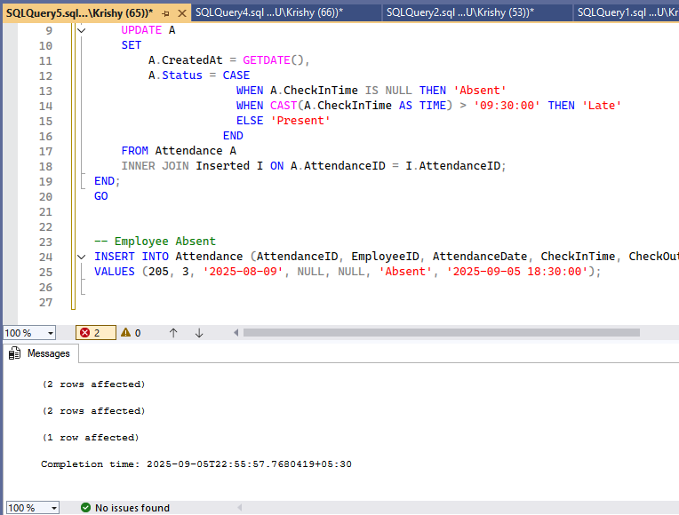

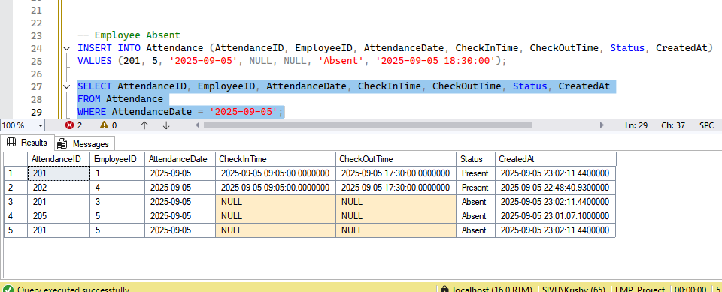

**Functions**

Here I created the function to calculate the total work hours

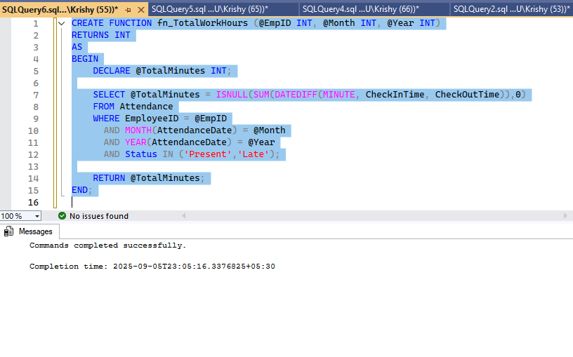

Fetched the total hours of Employee having Id = 1.

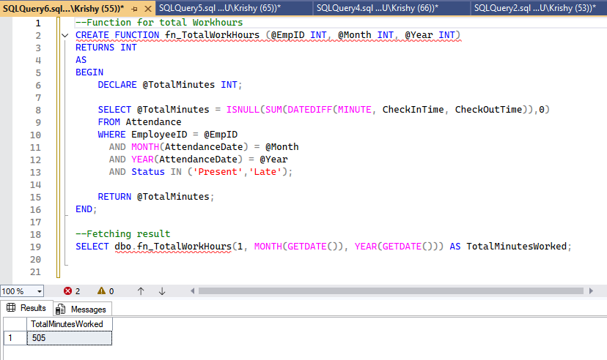

**Groupby & Having**

Have created the report for Department wise average attendance

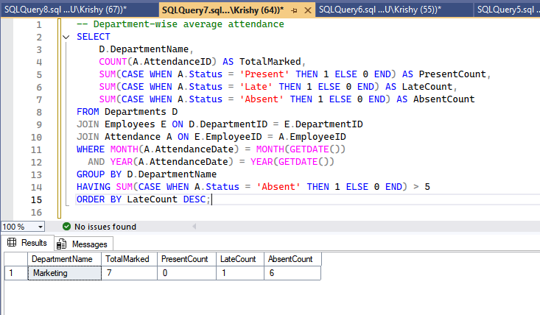

**Thank you!**